

Powered by TCPDF (www.tcpdf.org)

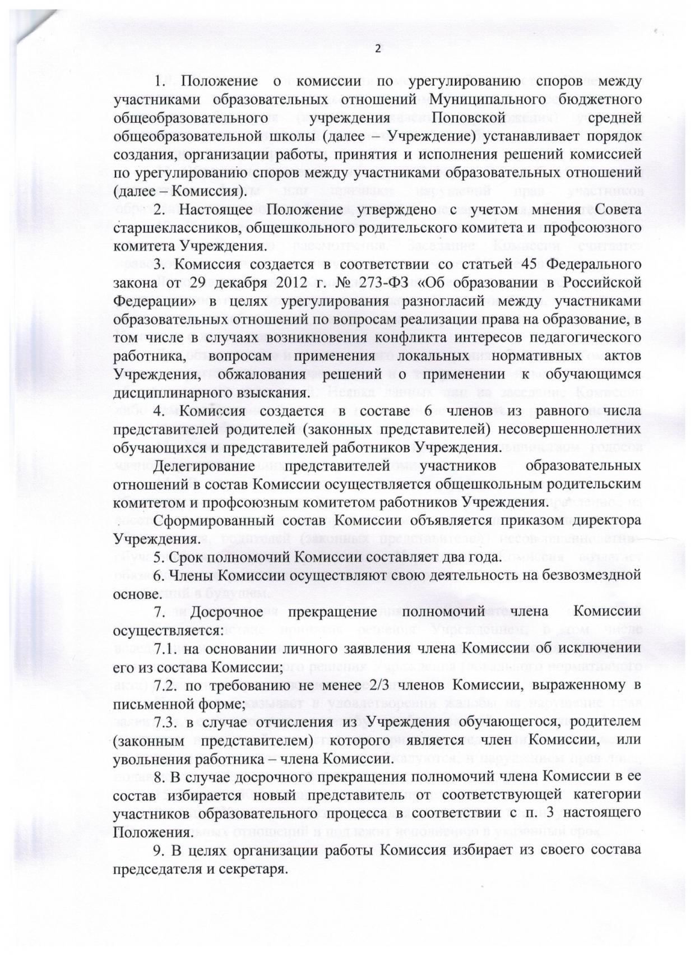

Powered by TCPDF (www.tcpdf.org)

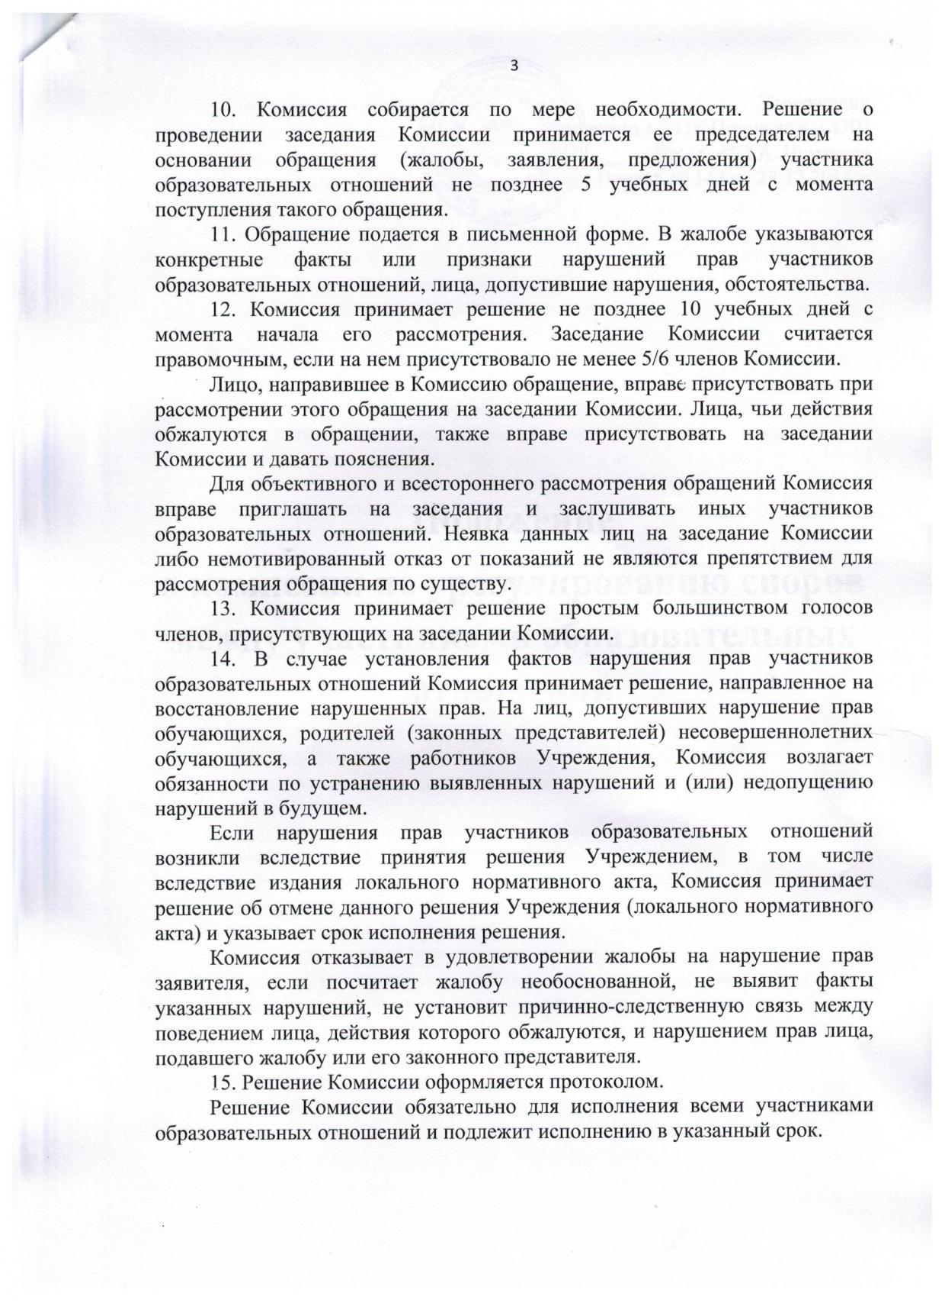

Powered by TCPDF (www.tcpdf.org)

